PRACTICAL -05
Aim:
To write a Python program to solve the 0/1 Knapsack Problem using Dynamic Programming.
Theory:
The 0/1 Knapsack Problem is a classic optimization problem where, given a set of items each with a weight and a value, the goal is to determine the maximum value that can be obtained by selecting items such that their total weight does not exceed a given knapsack capacity. In the 0/1 variant, each item can either be included whole or excluded entirely — it cannot be broken into fractions.
Dynamic Programming solves this problem efficiently by breaking it into overlapping subproblems and storing their results in a table (memoization), avoiding redundant recalculation. A 2D table dp[i][w] is built, where dp[i][w] represents the maximum value achievable using the first i items with a knapsack capacity of w. For each item, there are two choices:
- Exclude the item: the value remains the same as dp[i-1][w].
- Include the item (only if its weight ≤ w): the value becomes item's value + dp[i-1][w - item's weight].
The maximum of these two choices is stored at each step. This bottom-up approach gives a time complexity of O(n × W), where n is the number of items and W is the knapsack capacity — a significant improvement over the exponential time of the naive recursive approach.
Algorithm:
- Input the number of items, their weights, values, and the maximum capacity of the knapsack.
- Create a 2D DP table dp[n+1][capacity+1], initialized with 0 in the first row and first scolumn.
- For each item i from 1 to n, and for each capacity w from 0 to the maximum capacity:
  - If the weight of item i is less than or equal to w, set dp[i][w] = max(value[i] + dp[i-1][w - weight[i]], dp[i-1][w]).
  - Otherwise, set dp[i][w] = dp[i-1][w].
- The maximum value obtainable is stored in dp[n][capacity].
- Display the maximum value that can be carried in the knapsack.
Program Code:
def knapsack_dp(weights, values, capacity):
n = len(weights)
# dp[i][w] = max value using first i items with capacity w
dp = [[0 for _ in range(capacity + 1)] for _ in range(n + 1)]

for i in range(1, n + 1):
for w in range(capacity + 1):
# Option 1: don't include item i-1
dp[i][w] = dp[i - 1][w]

# Option 2: include item i-1, if it fits
if weights[i - 1] <= w:
dp[i][w] = max(dp[i][w],
dp[i - 1][w - weights[i - 1]] + values[i - 1])
return dp[n][capacity]
def knapsack_dp_optimized(weights, values, capacity):
n = len(weights)
dp = [0] * (capacity + 1)

for i in range(n):
# traverse weights in reverse so each item is only used once
for w in range(capacity, weights[i] - 1, -1):
dp[w] = max(dp[w], dp[w - weights[i]] + values[i]
return dp[capacity]
# Demo
if __name__ == "__main__":
weights = [1, 3, 10, 4]
values = [1, 10, 5, 7]
capacity = 8
print("Max value (2D DP): ", knapsack_dp(weights, values, capacity))
print("Max value (Optimized DP): ", knapsack_dp_optimized(weights, values,capacity))

Output:
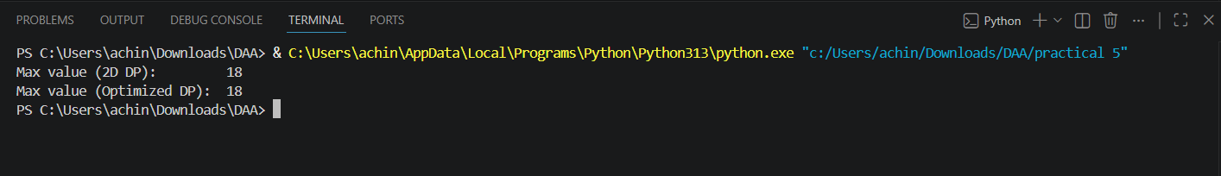

Result:
The program successfully solves the 0/1 Knapsack Problem using Dynamic Programming. By building a table of optimal solutions to subproblems, the algorithm efficiently determines the maximum value that can be accommodated within the given knapsack capacity, achieving a time complexity of O(n × capacity).

